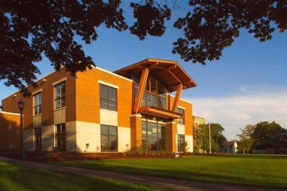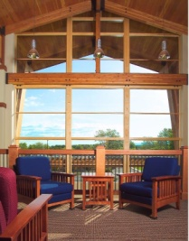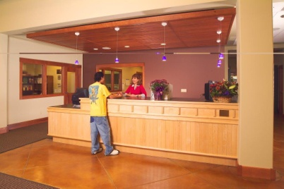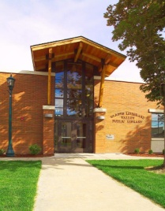
MILTON-FREEWATER, OREGON LIBRARY DIRECTOR
$71,652 TO $87,472 DOQ
PLUS EXCELLENT BENEFITS

APPLY BY NOVEMBER 1, 2019
11:00 a.m.

Milton-Freewater, OR

The City of Milton-Freewater, Oregon lies in northeast Oregon eight miles south of the City of Walla Walla, Washington, and thirty miles northeast of Pendleton, Oregon with only a twenty-minute drive to the beautiful Blue Mountains. Milton-Freewater is a community surrounded by wheat fields, vineyards and fruit orchards set against the beautiful Blue Mountains.

The City is governed by the Council/Manager form of government and enjoys a stable, supportive Council/Manager relation.

The Community
Long before the two towns of Milton and Freewater merged in 1951, settlers flocked to this area to take advantage of the fertile soil. Now situated within the acclaimed Walla Walla Valley wine appellation, the area is still well known for its agricultural bounty. Lots of sun in the summer and mild winters contribute to an almost perfect climate. According to the most recent census, our population is 7,050.

The City provides all City utilities, including electric service. City Light and Power is the oldest municipal electric utility operating in the State of Oregon and also offers some of the lowest consumer power rates in the northwest.

Two ski resorts, Bluewood and Spout Springs, are within a short driving distance. With skiing and snowmobiling in the winter and motorcycling in the summer, the mountains are great for year-round enjoyment. The area also offers bountiful opportunities for hunting, fishing, horseback riding and hiking.

Education is highly valued by the community with a unified school district including three elementary schools, a middle school and a high school. Fine colleges and universities are within close driving distance: Walla Walla Community College, Whitman College and Walla Walla University in the Walla Walla area, Blue Mountain Community College in Milton-Freewater & Pendleton, and Eastern Oregon University in LaGrande, Oregon.

The Library
The Milton Public Library was established in 1913 by the Woman’s Improvement Club. By the time the new Carnegie library building opened in 1918, the City of Milton had taken responsibility for operations. After Milton and Freewater merged in 1951, their libraries were consolidated into the Milton building. A new building, three times larger, replaced the old one in 2003. The Wayne and Gladys Valley Foundation of Oakland, California received naming rights in exchange for a $1.25 million gift to the building fund. The building is named in memory of Gladys Leibbrand Valley, who grew up in Milton-Freewater. The Library has over 47,000 physical items and 47,000 more downloadable ones in its collections. Through the Umatilla County Special Library District and the Sage Library System, library patrons can access more than 1.3 million items from 75 other public, school, academic and special libraries in eastern Oregon. The City’s library staff has been quite innovative in seeing ideas come to fruition, and they take great pride in the ability to provide print or non-print items as requested.

The Department has 3.93 FTEs with several volunteer staff and an operating budget of $400,000.

The Position
The Library Director reports directly to the City Manager, and is responsible for the day-to-day administration of the library department. This position directs, coordinates and is responsible for all work performed within the library.

Experience & Education
The ideal candidate will possess a Master’s degree in library science, or a related field, a minimum of three years of progressively responsible library management experience, or an equivalent combination of education and experience which demonstrates qualifications in finance, workforce development, and labor unions; excellent leadership, interpersonal, and communication skills and a commitment to teamwork within a municipal environment; considerable experience in various computer software packages, including Microsoft Word, Microsoft Excel and library automation software.

Candidates who can effectively demonstrate most but not all of these requirements are encouraged to apply. While public library experience is desired, those individuals from academic and special libraries are also encouraged to apply.

Compensation
- $71,652 TO $87,072 DOQ
- Medical, dental, vision insurance benefits - 90% paid by City.
- Long-term disability insurance
- Employee Assistance Program
- Sick leave (earn 1 day/month)
- Vacation 12 days/year first four years
- 12 paid holidays
- Employer paid life insurance
- Voluntary Deferred Compensation
- Employer paid Oregon State PERS Retirement

To Apply
The City of Milton-Freewater is an Equal Opportunity Employer. All qualified candidates are strongly encouraged to apply. To apply please send a resume, completed application and response to the supplemental questions to:

laurie.bubar@milton-freewater-or.gov, fax or mail to the number or address below. Applications for consideration are required to be in the Human Resource Department by 11:00 am, Friday, November 1, 2019. All information needed for this application process may be found at www.mfcity.com or received at City Hall in the Human Resource Department. EOE

City of Milton-Freewater
PO Box 6, 722 S. Main Street
Milton-Freewater, OR 97862

541-938-8243 HR Direct Line
541-938-8224 FAX
laurie.bubar@milton-freewater-or.gov
www.mfcity.com

